**Wiki page for Lab Asmt 8**

* Implement a web server proxy (related to your own project) to integrate data from at least two Rest services.

* Write at least two suitable Junit Test cases for the classes created.

**Please find the screenshots below:**

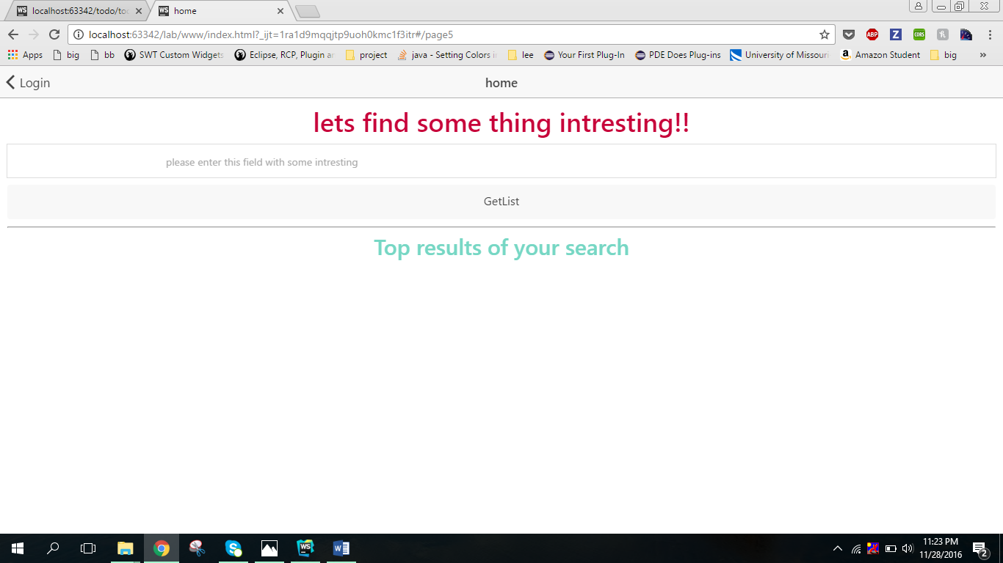

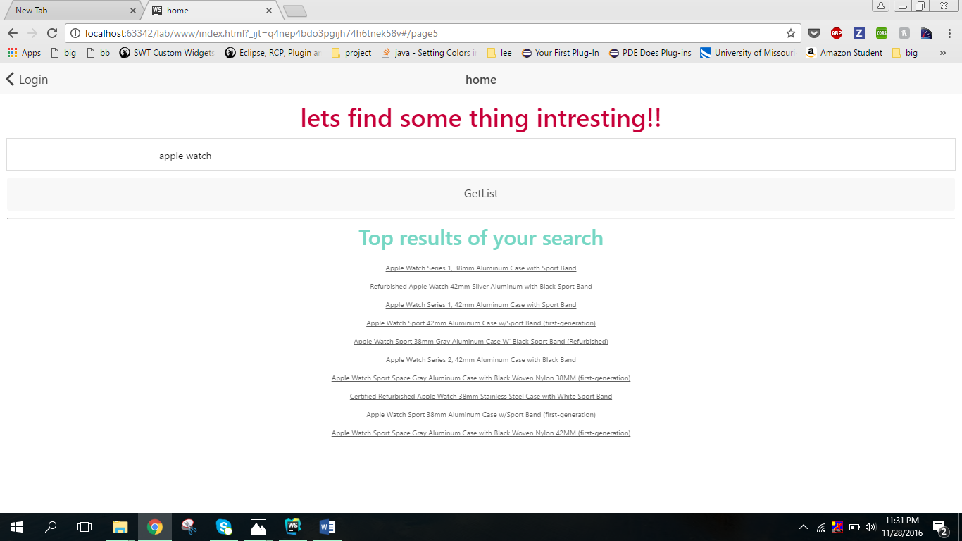

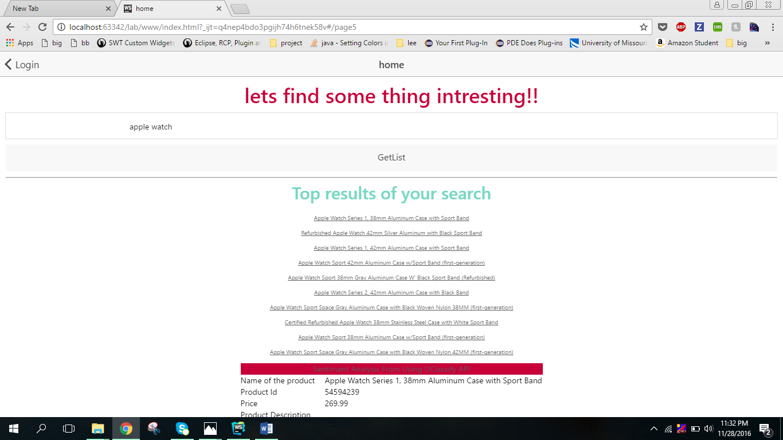

**Junit test cases:**

